Carlow Court Apartments at Emerald Vista
Carlow Court Apartments at Emerald Vista has 50 senior units and is located at 6880 Mariposa Circle in Dublin.

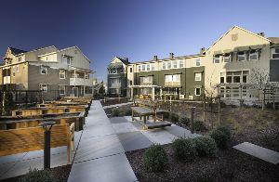

PROJECT DESCRIPTION
Emerald Vista is a master-planned community designed to serve a broad cross section of the Dublin community. Emerald Vista will reuse and transform the 24-acre Arroyo Vista public housing site into a vibrant, mixed-use, mixed-income community. This exciting new development will provide 180 affordable rental apartments for families and seniors. In addition, a Community Center, a Childcare Center, active open space areas, and access to a regional trail along Alamo Creek will be included.

Carlow Court and Wexford Way will be developed utilizing the latest green building techniques and materials, and is designed in accordance with Build it Greens GreenPoint Rating system. The project will include solar hot water and solar photovoltaics to reduce energy consumption in our project.

Senior residents living at Carlow Court will be provided with programs designed to help them age in place and live independently in a healthy and productive way for as long as possible. Eden Housing provides its residents with daily support and access to valuable resources within their communities. Additionally, all Eden Housing residents are eligible to apply for the Howard T. Collins Memorial Scholarship to further their educational and career goals.

Floor Plan | Square Footage | Monthly Rent Range | Waiting List Open | Section 8 Certificates & Vouchers Accepted | Move-in Specials
1 Bedroom, 1 Bath | 555 | $445 - $784 | No | No | N/A
Community Amenities include a community room, computer lab, exercise room and library.

